Incremental Backups
This section contains these topics:
- About Incremental Backups
- Multilevel Incremental Backups
- How Incremental Backups Work
- Differential Incremental Backups
- Cumulative Incremental Backups
- Incremental Backup Strategy

About Incremental Backups
An incremental backup reads the entire file and then backs up only those data blocks that have changed since a previous backup. You can use RMAN to create incremental backups of datafiles, tablespaces, or the whole database. Note that RMAN can include a control file in an incremental backup set, but the control file is always included in its entirety--no blocks are skipped.
During media recovery, RMAN examines the restored files to determine whether it can recover them with an incremental backup. RMAN always chooses incremental backups over archived logs. Note that RMAN does not need to restore a base incremental backup of a datafile in order to apply incremental backups to the datafile during recovery. For example, you can restore non-incremental image copies of the datafiles in the database, and RMAN can recover these datafiles with incremental backups.
The primary reasons for making an incremental backup are
- To save tape when using a media manager or disk space when making disk backups
- To save network bandwidth when backing up over a network
- When the aggregate tape bandwidth available for tape write I/Os is much less than the aggregate disk bandwidth for disk read I/Os
- To be able to recover changes to objects created with the NOLOGGING option (direct load inserts do not log redo, although they do change data blocks and so are captured by incremental backups)
- To reduce backup sizes for NOARCHIVELOG databases. Instead of making a whole database backup every time, you can make incremental backups. Note that incremental backups of a NOARCHIVELOG database are only legal after a consistent shutdown.
One effective strategy is to make incremental backups to disk and then run BACKUP BACKUPSET to copy the backups to a media manager. Then, you do not have the problem of keeping tape streaming that sometimes occurs when making incremental backups directly to tape. Because incrementals are not as big as full backups, you can create them on disk more easily.

Multilevel Incremental Backups
RMAN can create multilevel incremental backups. Each incremental level is denoted by an integer, for example, 0, 1, 2, and so forth. A level 0 incremental backup, which is the base for subsequent incremental backups, copies all blocks containing data. The only difference between a level 0 backup and a full backup is that a full backup is never included in an incremental strategy. If no level 0 backup exists when you run a level 1 or higher backup, RMAN makes a level 0 backup automatically to serve as the base.
A level n incremental backup in which n is greater than zero backs up either:
- All blocks changed after the most recent backup at level n or lower (the default type of incremental backup, which is called a differential backup)
- All blocks changed after the most recent backup at level n-1 or lower (called a cumulative backup)
Note:
In most circumstances, cumulative backups are preferable to differential backups because fewer incremental backups need to be applied during recovery.

The benefit of performing multilevel incremental backups is that RMAN does not back up all blocks all of the time. Since RMAN needs to read all of the blocks of the datafile, full backups and incremental backups take approximately the same amount of time.
Incremental backups at levels greater than zero only copy blocks that were modified. The size of the backup file depends solely upon the number of blocks modified and the incremental backup level.

How Incremental Backups Work
Each data block in a datafile contains a system change number (SCN), which is the SCN at which the most recent change was made to the block. During an incremental backup, RMAN reads the SCN of each data block in the input file and compares it to the checkpoint SCN of the parent incremental backup. RMAN reads the entire file every time whether or not the blocks have been used.
The parent backup is the backup that RMAN uses for comparing the SCNs. If the current incremental is a differential backup at level n, then the parent is the most recent incremental of level n or less. If the current incremental is a cumulative backup at level n, then the parent is the most recent incremental of level n-1 or less. If the SCN in the input data block is greater than or equal to the checkpoint SCN of the parent, then RMAN copies the block.
Note that one consequence of this mechanism is that RMAN applies all blocks containing changed data during recovery--even if the change is to an object created with the NOLOGGING option. Hence, making incremental backups functions as a safeguard against the loss of changes made to NOLOGGING tables.
See Also:
Oracle9i Database Concepts for more information about NOLOGGING mode

Differential Incremental Backups
In a differential level n incremental backup, RMAN backs up all blocks that have changed since the most recent backup at level n or lower. For example, in a differential level 2 backup, RMAN determines which level 1 or level 2 backup occurred most recently and backs up all blocks modified after that backup. If no level 1 is available, RMAN copies all blocks changed since the base level 0 backup. If no level 0 backup is available, RMAN makes a new base level 0 backup for this file. Incremental backups are differential by default.

Figure 5-5 Differential Incremental Backups (Default)
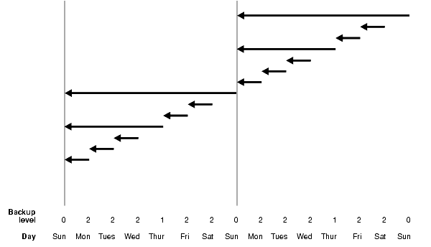
Text description of the illustration sbr81009.gif
In the example shown in Figure 5-5, the following occurs:
- Sunday
An incremental level 0 backup backs up all blocks that have ever been in use in this database.
- Monday
A differential incremental level 2 backup backs up all blocks that have changed since the most recent incremental backup at level n or less; in this case, the most recent incremental backup at level 2 or less is the level 0 Sunday backup, so only the blocks changed since Sunday will be backed up.
- Tuesday
A differential incremental level 2 backup backs up all blocks that have changed since the most recent incremental backup at level n or less; in this case, the most recent incremental backup at level 2 or less is the level 2 Monday backup, so only the blocks changed since Monday will be backed up.
- Wednesday
A differential incremental level 2 backup backs up all blocks that have changed since the most recent incremental backup at level n or less; in this case, the most recent incremental backup at level 2 or less is the level 2 Tuesday backup, so only the blocks changed since Tuesday will be backed up.
- Thursday
A differential incremental level 1 backup backs up all blocks that have changed since the most recent incremental backup at level n or less; in this case, the most recent incremental backup at level 1 or less is the level 0 Sunday backup, so all the blocks changed since the Sunday level 0 backup will be backed up.
- Friday
A differential incremental level 2 backup backs up all blocks that have changed since the most recent incremental backup at level n or less; in this case, the most recent incremental backup at level 2 or less is the level 1 Thursday backup, so only the blocks changed since the Thursday level 1 backup will be backed up.
- Saturday
A differential incremental level 2 backup backs up all blocks that have changed since the most recent incremental backup at level n or less; in this case, the most recent incremental backup at level 2 or less is the level 2 Friday backup, so only the blocks changed since the Friday level 2 backup will be backed up.
- The cycle is repeated for the next week.

Cumulative Incremental Backups
Oracle provides an option to make cumulative incremental backups at level 1 or greater. In a cumulative level n backup, RMAN backs up all the blocks used since the most recent backup at level n-1 or lower. For example, in a cumulative level 2 backup, RMAN determines which level 1 backup occurred most recently and copies all blocks changed since that backup. If no level 1 backup is available, RMAN copies all blocks changed since the base level 0 backup.
Cumulative incremental backups reduce the work needed for a restore by ensuring that you only need one incremental backup from any particular level. Cumulative backups require more space and time than differential backups, however, because they duplicate the work done by previous backups at the same level.

Figure 5-6 Cumulative Incremental Backups
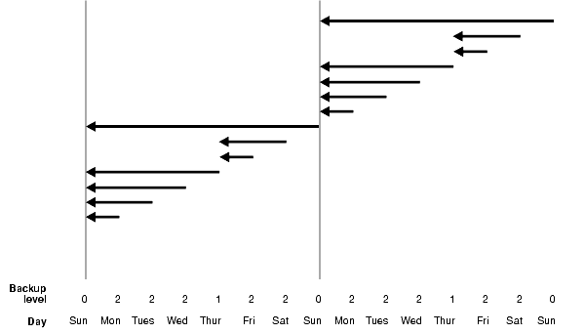
Text description of the illustration sbr81010.gif
In the example shown in Figure 5-6, the following occurs:
- Sunday
An incremental level 0 backup backs up all blocks that have ever been in use in this database.
- Monday
A cumulative incremental level 2 backup backs up all blocks that have changed since the most recent incremental backup at level n-1 or less; in this case, the most recent incremental backup at level 1 (2 minus 1) or less is the level 0 Sunday backup, so only the blocks changed since Sunday will be backed up.
- Tuesday
A cumulative incremental level 2 backup occurs. This backs up all blocks that have changed since the most recent incremental backup at level n-1 or less; in this case, the most recent incremental backup at level 1 (2 minus 1) or less is the level 0 Sunday backup, so all the blocks changed since Sunday will be backed up. (This backup includes those blocks that were copied on Monday, since this backup is cumulative and includes the blocks copied at backups taken at the same incremental level as the current backup).
- Wednesday
A cumulative incremental level 2 backup backs up all blocks that have changed since the most recent incremental backup at level n-1 or less; in this case, the most recent incremental backup at level 1 (2 minus 1) or less is the level 0 Sunday backup, so all the blocks changed since Sunday will be backed up. (This backup includes those blocks that were copied on Monday and Tuesday, since this backup is cumulative and includes the blocks copied at backups taken at the same incremental level as the current backup).
- Thursday
A cumulative incremental level 1 backup backs up all blocks that have changed since the most recent incremental backup at level n-1 or less; in this case, the most recent incremental backup at level 0 (1 minus 1) or less is the level 0 Sunday backup, so all the blocks changed since Sunday will be backed up.
- Friday
A cumulative incremental level 2 backup backs up all blocks that have changed since the most recent incremental backup at level n-1 or less; in this case, the most recent incremental backup at level 1 (2 minus 1) or less is the level 1 Thursday backup, so all the blocks changed since Thursday will be backed up.
- Saturday
A cumulative incremental level 2 backup backs up all blocks that have changed since the most recent incremental backup at level n-1 or less; in this case, the most recent incremental backup at level 1 (2 minus 1) or less is the level 1 Thursday backup, so all the blocks changed since Thursday will be backed up.
- The cycle is repeated for the next week.

Incremental Backup Strategy
Choose a backup scheme according to an acceptable MTTR (mean time to recover). For example, you can implement a three-level backup scheme so that a full or level 0 backup is taken monthly, a cumulative level 1 backup is taken weekly, and a cumulative level 2 is taken daily. In this scheme, you never have to apply more than a day's worth of redo for complete recovery.
When deciding how often to take full or level 0 backups, a good rule of thumb is to take a new level 0 whenever 50% or more of the data has changed. If the rate of change to your database is predictable, then you can observe the size of your incremental backups to determine when a new level 0 is appropriate. The following query displays the number of blocks written to a backup set for each datafile with at least 50% of its blocks backed up:
SELECT FILE#, INCREMENTAL_LEVEL, COMPLETION_TIME, BLOCKS, DATAFILE_BLOCKS
FROM V$BACKUP_DATAFILE
WHERE INCREMENTAL_LEVEL > 0 AND BLOCKS / DATAFILE_BLOCKS > .5
ORDER BY COMPLETION_TIME;

Compare the number of blocks in differential or cumulative backups to a base level 0 backup. For example, if you only create level 1 cumulative backups, then when the most recent level 1 backup is about half of the size of the base level 0 backup, take a new level 0.

